Navigating the New ACCME Structured Abstract for Performance-in-Practice Submissions

By
Denise Doyle, CCMEP and Judy Sweetnam, M.Ed., CCMEP

The Structured Abstract is a new tool introduced by the ACCME in 2014 in response to engagement with the CME community. It is intended to simplify, clarify and make more explicit the information needed by the ACCME to verify providers’ Performance-in-Practice. While the ACCME recognizes that the maintenance of adequate documentation of compliance is labor- and time-intensive, it is critical to the credibility and overall validity of the accreditation system.
Providers are free to choose whether to use the new structured abstract or the old label system, although the ACCME asks providers to choose one approach (structured abstract or labels) for all of the P-i-P activities selected by the ACCME. So, if you have begun the process using labels and would like to change to using the structured abstract, you do not need to revise or re-do the activity documentation that already has been labeled. However, as an editorial comment, we are very positive about the new abstract system and recommend that CME providers embrace it and begin using it immediately. As a matter of practical implementation of the abstract system, it is suggested that a new Abstract format be opened immediately upon the start of planning and that it be completed as the process ensues. In that way, by the time the activity is completed, all necessary documentation of compliance is complete and ready to provide to the ACCME when requested.

Overview to the Structured Abstract
The structured abstract is a document that does not contain any new requirements or expectations, but we note that many CME providers have been merely checking boxes related to needs and intended results, and now you must state those conclusion in a brief narrative. It asks you to describe how you have fulfilled four areas of ACCME expectations for an activity. The information for the four criteria will be drawn from your existing file documentation. The format for the abstract asks you to describe, in just a few words, the evidence that you have acquired in planning a CME activity and then attach examples that demonstrate that you've done it. It is suggested that planner or writers that are documenting the planning process be provided with a summary template that mimics the questions asked in the Abstract so that information is readily available (a sample planning document that reflects the new Abstract System can be downloaded as per the instructions and link contained at the end of this article).
Generally, the abstract is designed to simplify the demonstration of a provider’s identification of relevant financial relationships for all individuals in control of the content of CME activities. By completing the table for all persons in control of content, and including a single example of each type of form or method used to identify any relevant conflicts of interest, you will have met the expectation of compliance for this section of the Abstract.
If those who have an influence over the content of the activity have no conflicts of interest, or if the individual’s relationship (including their spouse or partner) does not constitute a relevant financial relationship with an ACCME-defined commercial interest, then there is no need to complete the fields for “name of the commercial interest” and “nature of relationship.” If you already have the information required for this table electronically, you may include it and do not need to fill out the fields in this table. As an extra tool to support CME providers, we have developed a fillable form that mimics the disclosure section of the abstract and you may download it from our website as indicated at the end of this article.
A single Structured Abstract can be used for complex activities; however, CME providers can also prepare separate structured abstracts for different tracks of a large annual meeting. Providers taking this approach should be sure that each structured abstract includes the required information and attachments.

The Abstract Form—Dissected
The first part of the abstract requires completion of fields within the Abstract, while the second section requires providers to provide brief summaries of the planning process. The third section concerns commercial support while the fourth lists the required six-to-nine attachments to the Abstract. Once completed, the abstract, along with the required attachments, fulfills the ACCME’s expectations for activity-specific documentation.
The following describes the type of evidence that should be submitted for each of the four sections referenced above:
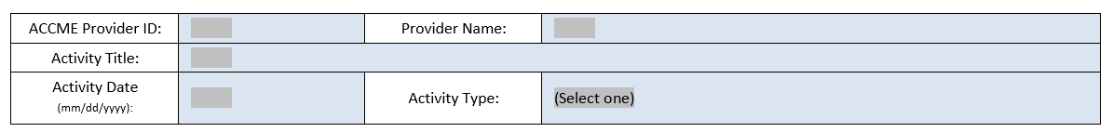
- The first section of the structured abstract asks the provider to include information about its organization and about the CME activity for which evidence is being submitted as shown in Figure 1.
Figure 1

- In the second section, information is entered about the planning process for the selected activity. Specifically, the provider is asked to summarize information related to:
- Professional practice gaps and the underlying educational needs (Criterion 2)
- What the activity was designed to change in learners’ or patient outcomes (Criterion 3)
- The rationale for the format selected for the activity (Criterion 5)
- The physician competencies the activity’s content addressed (Criterion 6).
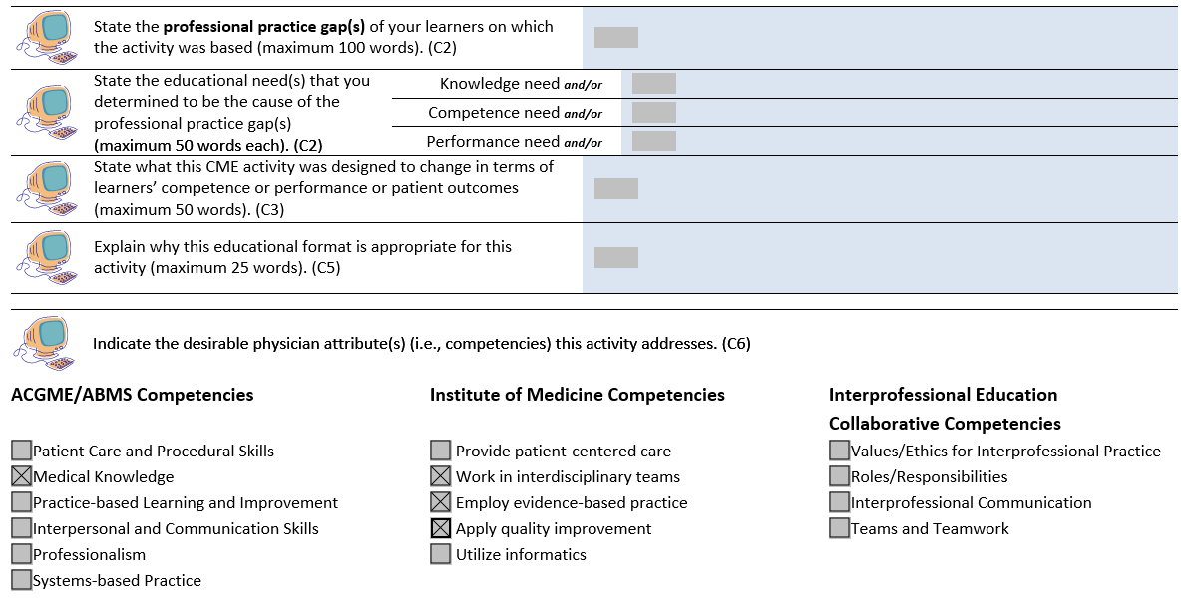
For Criterion 2, providers are asked to describe at least one underlying educational need in the abstract—knowledge, and/or competence, and/or performance. Depending on the activity, there may be one or two or three completed fields (see Figure 2). Importantly, for those providers who are used to merely checking a box that indicates the underlying cause of the gap, a brief narrative of your understanding of those cause(es) is now required.
Figure 2
- The next section of the abstract requires information about compliance with the Standards for Commercial Support (SCS) for the activity. If the activity was commercially supported, then the table on the abstract must be completed to describe all sources of commercial support. One row must be completed for each ACCME-defined commercial interest that provided commercial support for the activity. The name of the commercial interest is specified as well as the dollar amount of monetary support received. An X is placed in the checkbox if the activity received in-kind support. If the information required for this table is available electronically, it may be included instead of completing the fields in the abstract for commercial support. Be sure that all LOAs are signed and dated prior to the start of the activity or that electronic LOAs are date-stamped.

- The last section of the structured abstract is a list of attachments to include with the completed form. Attachments 1-6 must be included for all CME activities. Attachments 7-9 are included only if the activity was commercially supported. Specifically:
- Attachment 1: Activity content from the agenda or brochure [NOTE: only include the page or pages from course materials with the agenda and not other unrelated pages]
- Attachment 2: The form used to identify relevant conflicts of interest [NOTE: only one completed form from the specific activity is required; the full list of everyone that completed the form and their role in the activity is contained the table from the Abstract as shown in Figure 3]
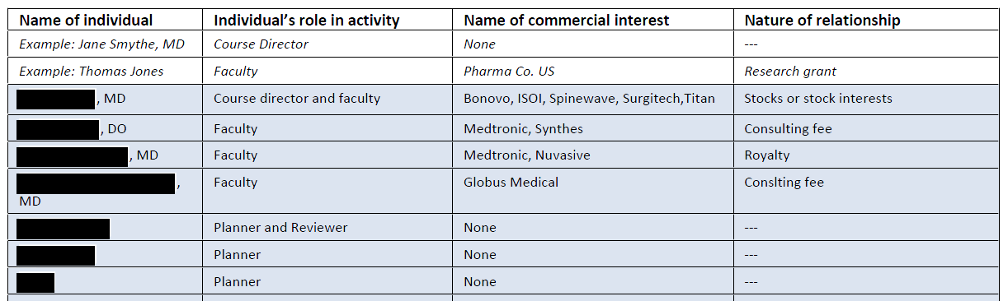
Figure 3
- Attachment 3: The mechanism/tool or form used to resolve conflicts of interest [NOTE: this can include a summary table demonstrating relevant COI and how it was resolved plus a copy of the actual mechanism used to resolve conflicts such as a completed Content Review Form for the activity]
- Attachment 4: The disclosure information provided to learners [NOTE: Only include the actual page from course materials with disclosures provided to learners that matches the Disclosure Table shown in Figure 3 above and no other unrelated pages]
- Attachment 5: Data or information about the changes in competence, performance and/or patient outcomes [NOTE: if the planning information shown in Figure 2 above indicates that the changes anticipated by learners includes competence improvements and/or performance improvements and/or improvements in patient outcomes, then be sure to match your outcomes measurements tools to those commitments; be sure that the summary data included in this attachments includes an analysis of the outcomes results]
- Attachment 6: The ACCME accreditation statement as provided to learners [NOTE: only include the page from course materials with the correct disclosure statement—either directly provided or jointly provided]
For Commercial Supported Activities . . .
- Attachment 7: The income and expense statement [NOTE: be sure to include all income and expenses—not just expenses—and to break down income by commercial support, registration fees (if any) and any other major category of income]
- Attachment 8: All letters of agreement (LOAs) {signed, dated and if on a form provided by the supporter, vetted for compliance with the SCS]
- Attachment 9: The disclosure of commercial support to the learners

Documentation of RSS and Large Annual Meeting Activities using the Abstract Template
An RSS, by definition, is an activity that is comprised of a number of sessions. The ACCME expects the provider to demonstrate compliance at the activity level, in whatever manner the provider chooses to fulfill the accreditation requirements. This is a similar process for what the ACCME would expect, for example, for a large annual meeting with multiple sessions. The ACCME does not require demonstration of each requirement at each session, but it does require that the provider present evidence that:
- The RSS or annual meeting is based on needs that underlie professional practice gaps
- The accreditation statement is communicated to the learners
- All persons in control of content have been disclosed to the provider and that the provider has disclosed this information to learners [NOTE: complete disclosure from all sessions is required but since most persons that affect content in an RSS have no relevant financial relationships, one can summarize the information such that a statement could be included in evidence that for 40 of 52 sessions persons disclosed that they had no relevant relationships to disclose and in the other 12 sessions the following persons disclosed relationships and then show that information]
- All conflicts of interest have been resolved
However, the ACCME does expect providers to submit all written agreements for any commercial support received for all or part of the RSS. When using the structured abstract for performance-in-practice for an RSS or large annual meeting, the ACCME will be looking for the provider to submit or describe the information it uses (or reviews through an internal monitoring system) that demonstrates compliance for the accreditation requirements in each RSS selected.
For the structured abstract, the ACCME asks that both the abstract fill-form and all appropriate attachments be completed and submitted in one compiled and bookmarked, electronic Adobe Acrobat PDF file, as illustrated below.
For the ACCME Abstract Format, the fillable form for disclosure of all persons that affect content (that exceeds the number of spaces provided in the abstract), a sample planning document that conforms to the new Abstract System, a checklist of potential documents to be included for each abstract attachment, and sample header formats for use in compiling the completed abstract for submission to the ACCME, please click on this link (www.PassinAssociates.com/downloadmmm) and download those forms as desired.
-30-

Denise Doyle is an associate and Judy Sweetnam is a senior associate and director of training with Steve Passin & Associates, based in Newtown Square, PA. Contact Denise at doyle@passinassociates.com and Judy at swetetnam@passinassociates.com.
‘Performance-in-Practice’ is the phrase used by the ACCME to collect evidence of compliance with the ACCME Criteria for Accreditation and the Standards for Commercial Support, usually associated with the submission of a self-study for accreditation or reaccreditation.

